55th Annual Mohawk Young Farmers Auction
►►CONSIGNMENTS NEEDED◄◄
Saturday, August 9, 2025 @ 10am
Location: Two miles north of Sycamore, OH at Mohawk Local School on Ohio SR 231
For more information, contact:
Caleb Bollinger 419-731-3444; Dave Hohman 419-397-2235 or Doug Walton 419-294-0007
mohawkyoungfarmers@gmail.com or office@waltonauctionco.com
Call or email NOW so that your items are advertised!
If your item is $2,000 or more, submit three photos for online bidding.
Deliver items: Thurs., Aug. 7th (4-9p); Fri., Aug. 8th (8a-9p); or Sat., Aug. 9th (8a-10a)
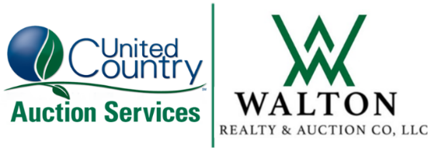
TERMS: Cash or check. Lunch/Restroom. Loader Available.
227 W. Wyandot Ave., Upper Sandusky, Ohio 43351
Phone: 419-294-0007

office@waltonauctionco.com
ucwaltonrealtyandauction.com

