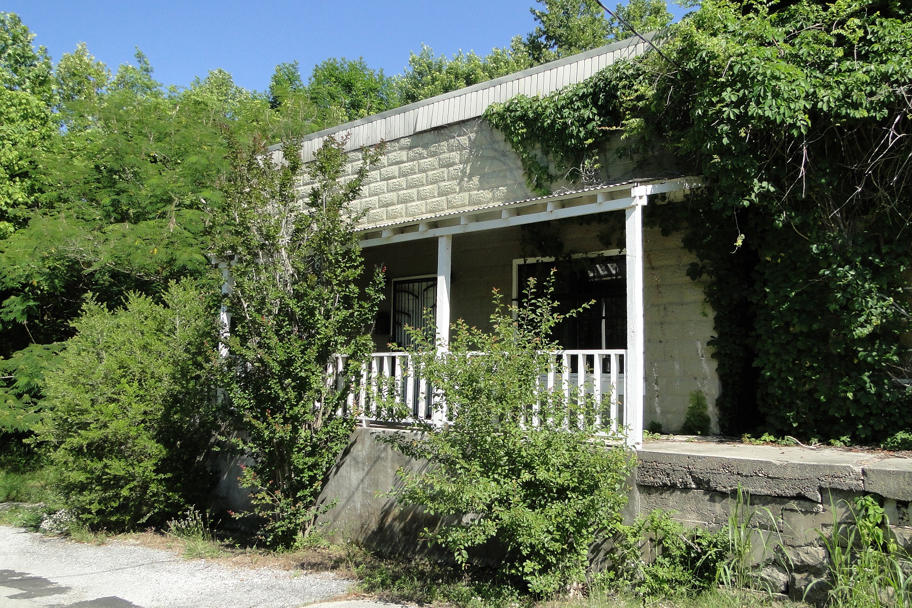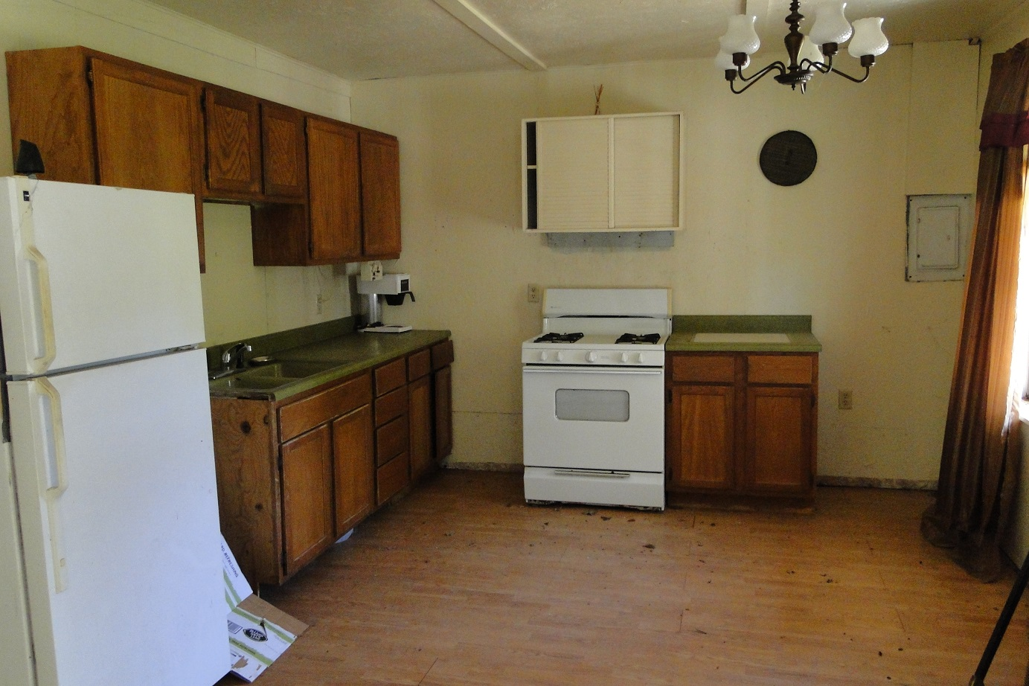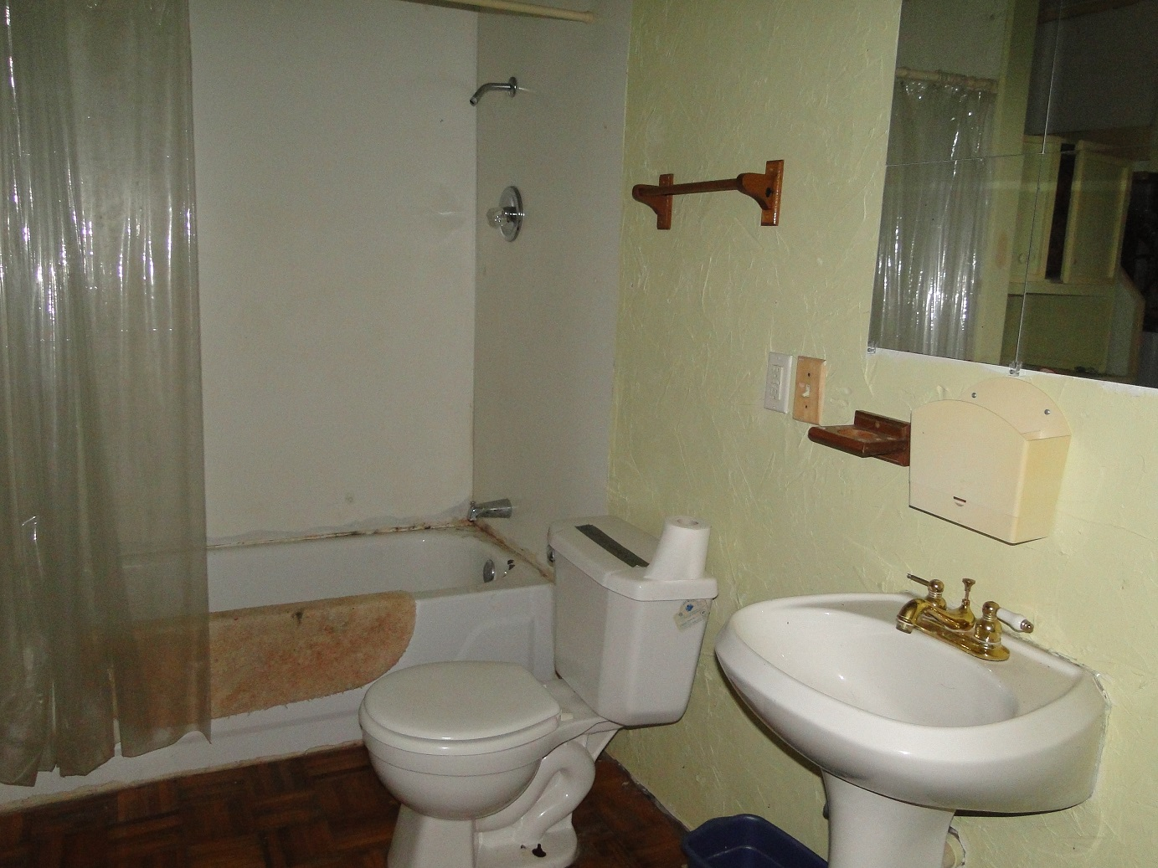
Information deemed accurate, but subject to errors, omission, prior sale, price changes or withdrawal without notice.
Property Shown By: United Country Ozark Realty, Inc
870-368-4155

http://www.ozarkrealtyinc.com

DOWNTOWN CALICO ROCK
2 BEDROOM 1 BATH
WALKING DISTANCE TO PUBLIC ACCESS OF WHITE RIVER
NEEDS SO FIXING AND FINISHING

David B. Sharp/Broker
Cody Cooper/ Agent

No One Knows The Country Like We Do
OLD ARKANSAS
HISTORIC BUILDING

$19,900
5303

