United Country Ozark Realty, Inc.
Information Sheet

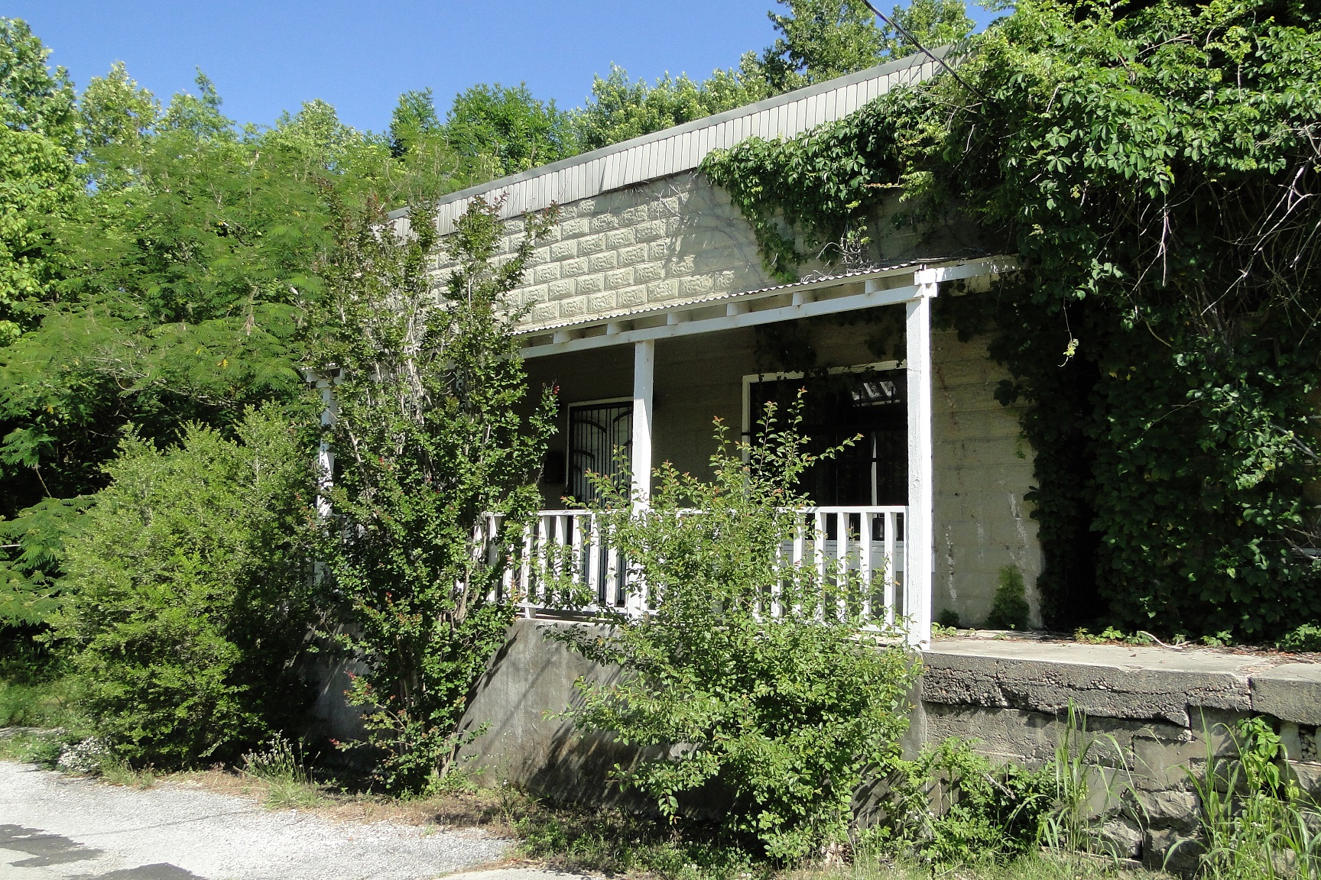United Country Ozark Realty, Inc.
PO Box 158
Melbourne, AR 72556

Phone: 870-368-4155

Fax: 870-368-4165

Email: ozarkrealtyinc@gmail.com

LISTING # 5303

PRICE $ 19,900

PROPERTY ADDRESS: 131 WALNUT ST. CALICO ROCK, AR 72519
Land | Home
Acres: 3 LOTS  Water Source: CITY  Fencing: NONE  Well vs City Water: CITY  Septic vs Sewer: SEWER  Closest Town: CALICO ROCK  Type of Road: BLACKTOP  Amt. of cleared land: -  Amt. of timbered land: -  Outbuilding(s): NONE  Taxes: $550  Type of Internet Svce: DSL  Television: CABLE  Sq. Ft.: 1,200  *Dimensions and/or square footage supplied by the County Tax Asessor Office  Age of Home: UNKNOWN  Termite: AVAILABLE | Bedrooms: 2  Baths: 1  Living Room Flooring: -  Kitchen Flooring: -  Kitchen Cabinets: WOOD  Type of Heat: -  Fireplace: NO  Type of Air: -  Type of Ext. Siding: CONCRETE BLOCK  Roof: SHINGES  Foundation: CONCRETE  Basement: NO  Nat. Gas vs LP: -  Garage/Carport: NONE  Appliances Staying: ALL
Comments: OLD ARKANSAS HISTORIC BUILDING
Historic building located in the downtown area of Calico Rock, Arkansas. Property is within walking distance to the public access of White River under the bridge at Calico Rock. Building has been converted into an apartment with 2 bedrooms and 1 bath. It does need some fixing and finishing but is livable now. If you are a trout fisherman, this would be a perfect fishing place with the river and boat rentals about a block walk. And the price is unbelievable at $19,900

