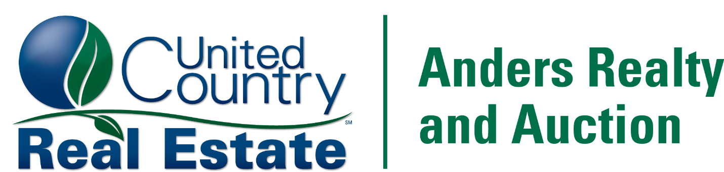

Buyer’s Broker Incentive Program for United County Anders Realty & Auction
Broker Registration Form

Date, Time, and Name of the Auction:
Company Name:
Company Address:
Email:

Client (Buyer/Bidder Information)
Client Name:
Address:
Phone:
Email:
Property Idenification:

Broker Participation Guidelines
- A commission/referral will be paid based on the following schedule to any properly Virginia licensed real estate brokerage who submits his or her Broker Registration Form according to the guidelines as outlined below and whose client is the successful purchaser of the property (s). This client must close on the property (s) and must pay the total contract price for the property (s).
- Two percent (2%) commission will be paid on the High bid. (Ex. $100,000 + 10% Buyers Premium = $110,000 Contract Price. Commission due to referral agent is $2,000 which is 2% of $100,000.)
- The broker commission/referral will not exceed (2%) percent commission received from the Total Bid Price of the property(s) purchased by that broker’s client.
- In order to be entitled to any commission/referral, the broker must:
- Register his or her client by filling out the Buyer’s Broker Incentive Program form in full, including the signature of the Broker’s Buyer/Bidder on the form.
- Submission of the Buyer’s Broker Incentive Program form must be delivered to: United Country Anders Realty & Auction PO Box 817 Wytheville, VA 24382 or by email at kevin@dalton2.com within 48 hours of the end of the auction. Broker forms arriving after the deadline will not be honored.
- Agent must attend ALL property viewings.
- Registered bidder has not already been in contact with Auctioneer or registered.
- A broker/agent may not represent themselves or their spouse in this transaction.
- Abide by the guidelines outlines herein.
- This form does not register buyers for the auction. It simply notifies the auctioneer that the bidder is working with a referring agent. Bidders will need to register for the auction at www.andersrealty.com to bid.
- The broker, by placing his or her signature below, certifies, agrees, and acknowledges that:
- The broker will not claim any exceptions to the procedures outlined in this document unless made in writing and signed by seller.
- No oral registration will qualify broker for commission/referral.
- The broker’s commission/referral will be due at the final closing of the property(s). purchased by the broker’s client after all consideration is paid in full.
- Only the first registration of a prospective client will be accepted and honored.
- The commission/referral will be payable only at closing and will be disbursed by the escrow agent.
- The broker will hold harmless and indemnify United Country Anders Realty & Auction from any and all claims with regard to such commission/referral.
- The broker will be paid a commission/referral only as set forth under these guidelines and only as pertaining to the specific property(s) being auctioned.
- The broker will not receive a commission/referral without the signature of the client on the Buyer’s Broker Incentive Program form.
- The broker cannot participate in the Buyer’s Broker Incentive Program and receive any commission/referral in conjunction with and other co-brokerage or referral agreement between United Country Anders Realty & Auction and broker.
- The broker will be representing the buyer/bidder (client) listed above as his or her agent.
- The broker is not a subagent of United Country Anders Realty & Auction and represents his or her client (buyer/bidder) as a buyer’s agent.
- The broker’s client (buyer/bidder), by placing his or her signature below, certifies, agrees, and acknowledges that:
- He or she has inspected the premises of the subject property(s).
- Auction is “Subject to Confirmation” being sold “As-Is” and contract will not be contingent upon financing or inspections.
- United Country Anders Realty & Auction represents the seller in this transaction.
- Commission/referral shall be paid only to the broker representing client (buyer/bidder) as acknowledged in this form.
- He or she shall hold harmless and indemnify United Country Anders Realty & Auction and seller from any and all representation made by the buyer’s broker.
- Auction day announcements override any comments or statements posted in Bidder’s Packet, websites, or advertisements.
- For further information or questions please call Kevin Dalton at 276-228-3242.

Buyer/Bidder Signature:

Broker/Agent Signature:

Auction Company Representative:

