

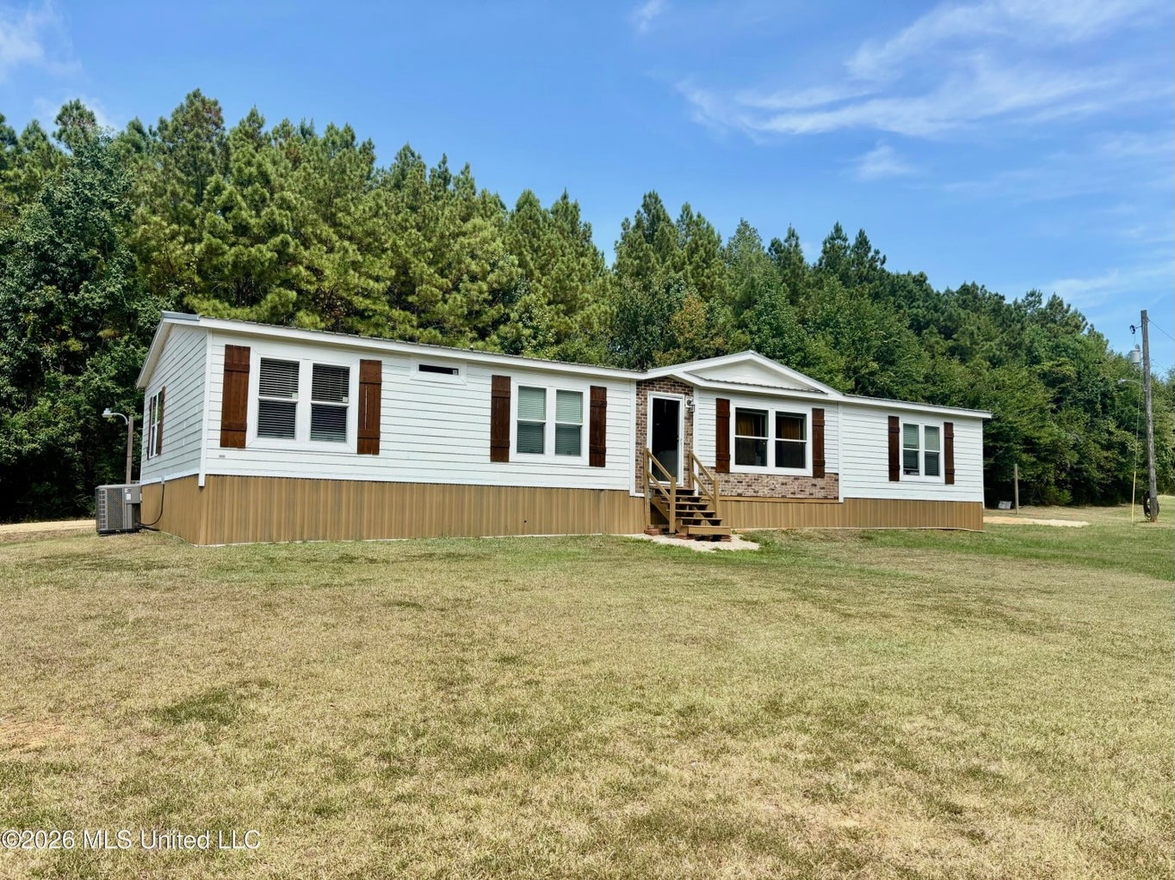
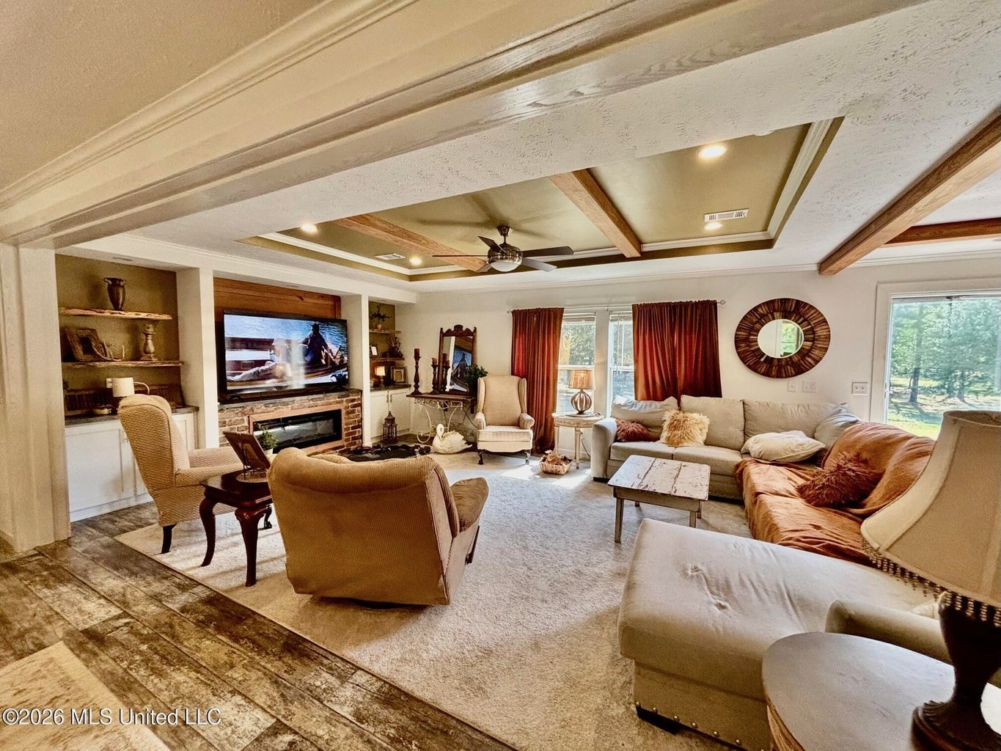
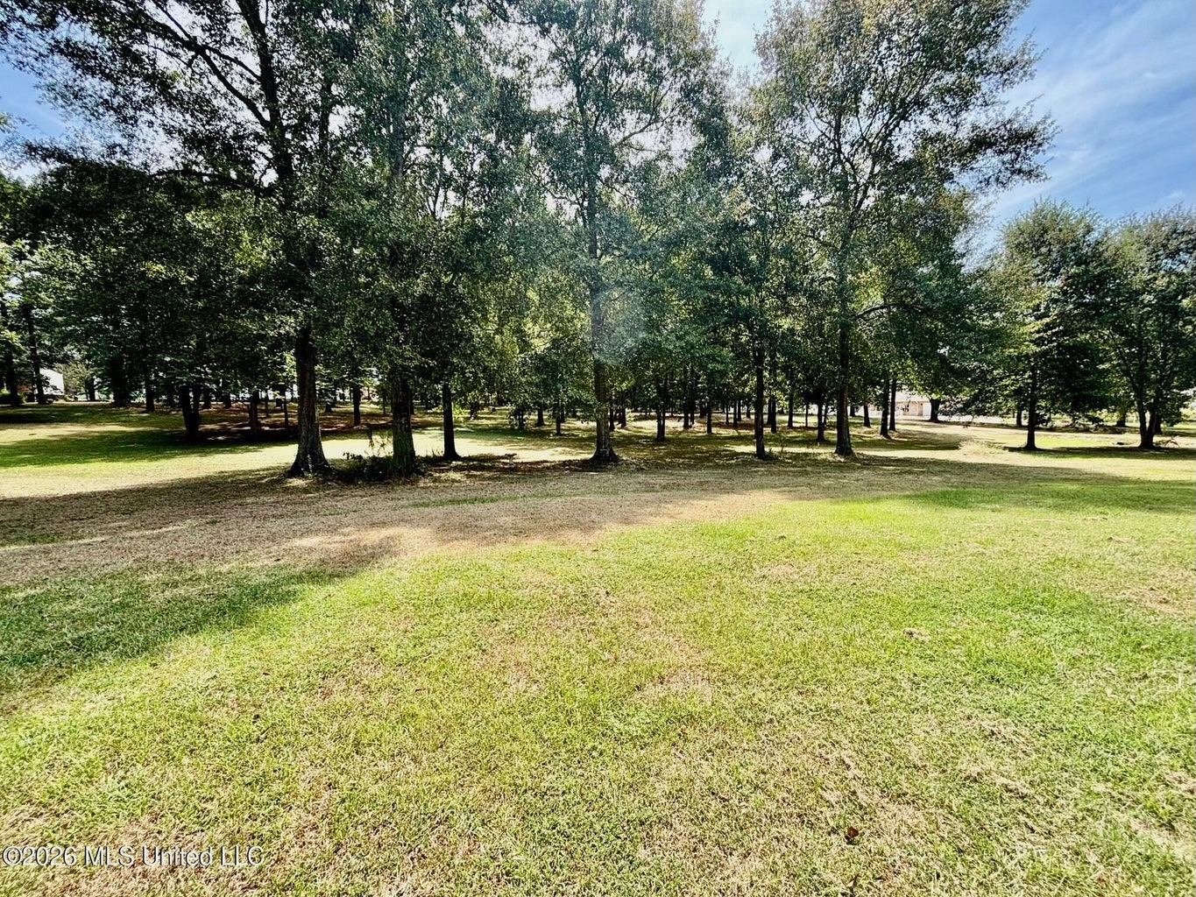
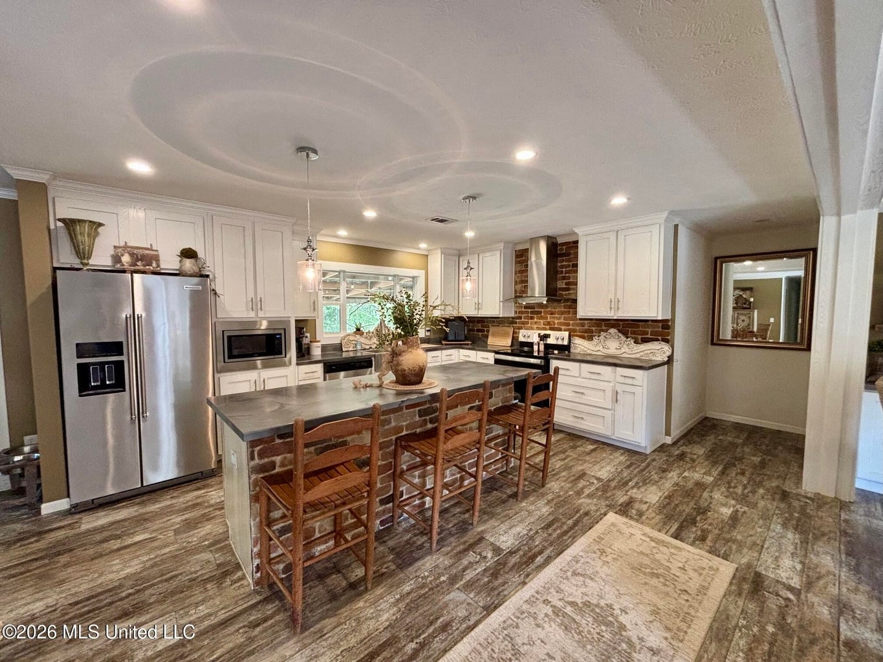
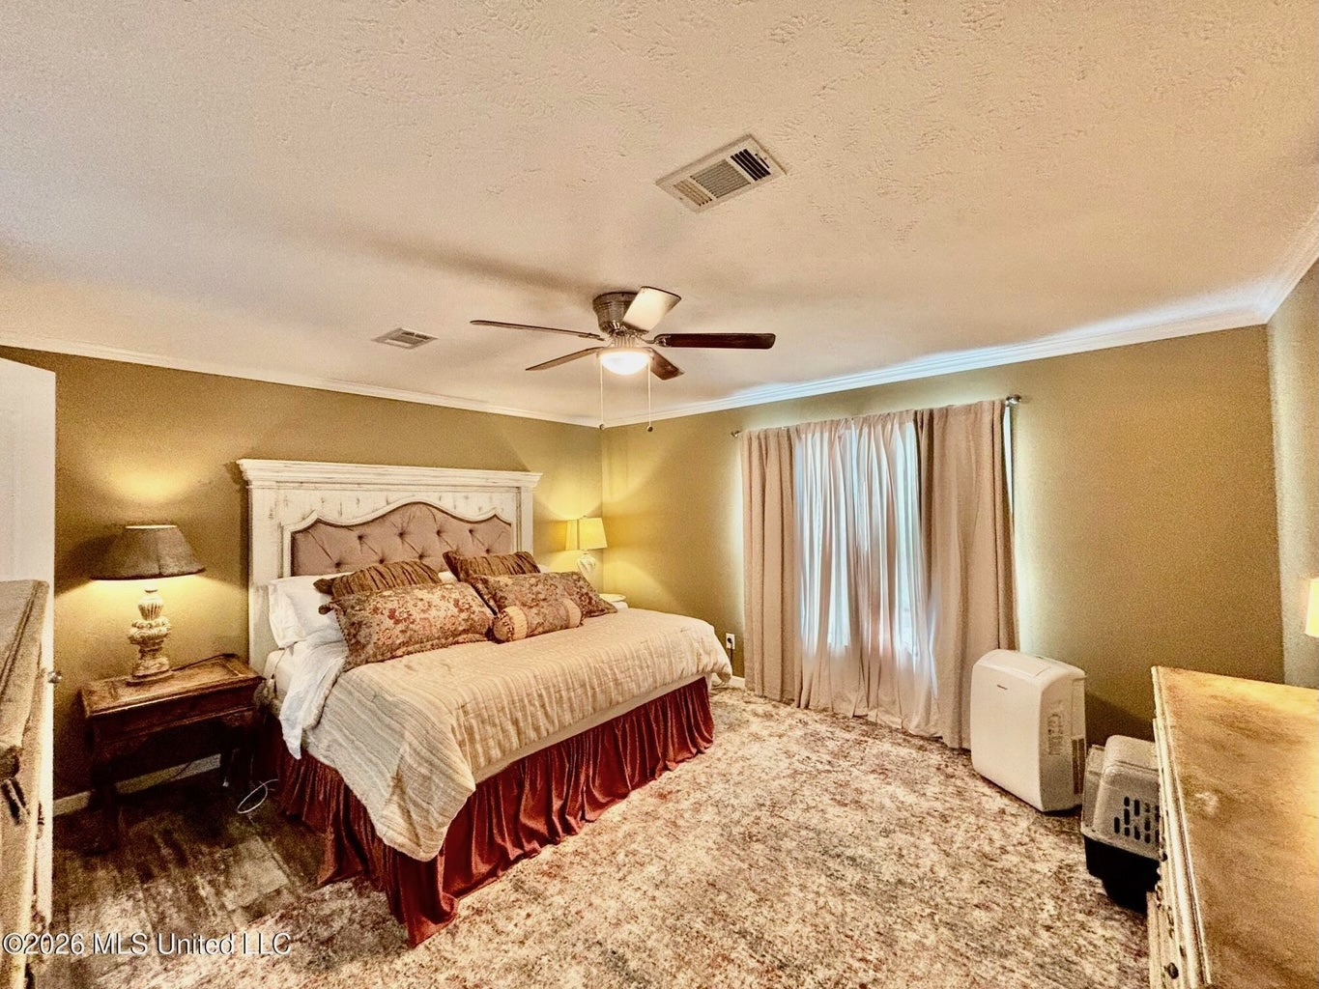
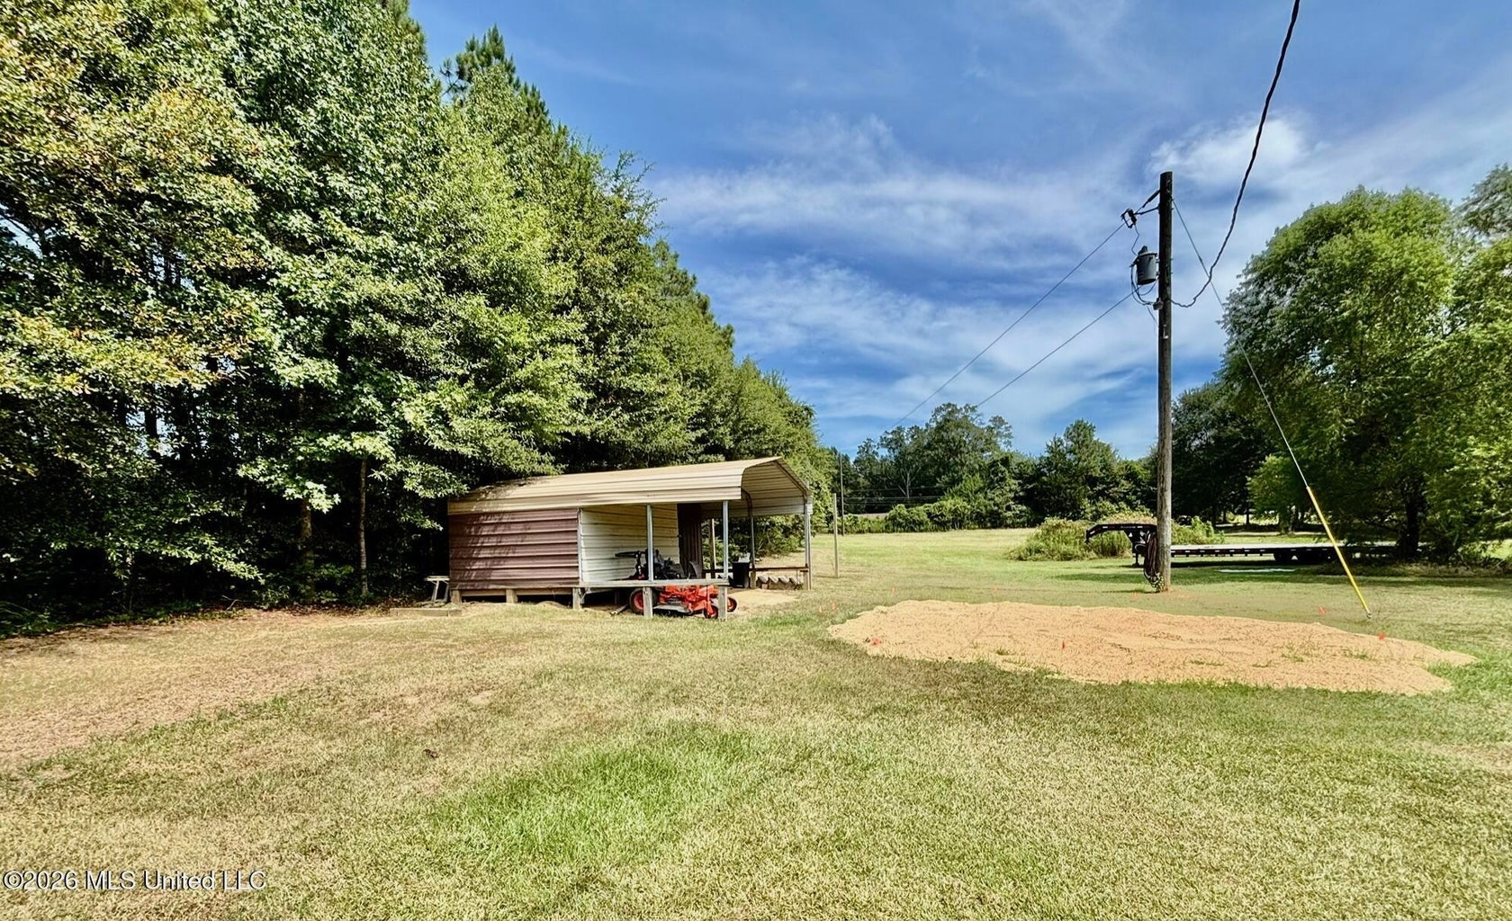
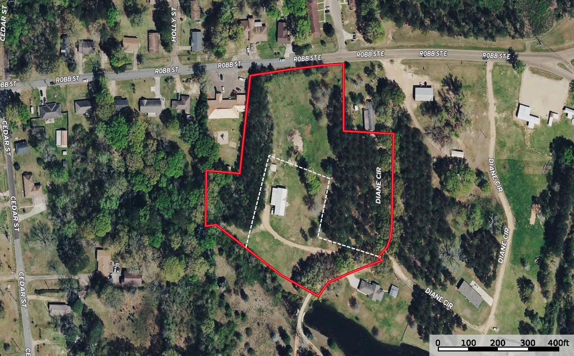

4 Bed/2.5 Bath
2.0± Acres
MLS #4160167

Danielle Burnette dandynburn@gmail.com
Office: (601) 250-0017
Cell: (601) 249-7061
SouthernStatesRealty.com
1014 Diane Circle, Summit, MS

Welcome home to this very well-kept 2020 Winston double-wide offering approximately 2,190 square feet of comfortable living space on 2+/- private acres in Pike County, Mississippi only minutes from Southwest Mississippi Community College. Tucked away off the road, this property provides the peace and privacy you've been looking for while still offering plenty of usable outdoor space. Inside, you'll find a spacious 4-bedroom, 2.5-bath floor plan with a large, open-concept living and dining area that is perfect for family gatherings and entertaining. The home features a modern kitchen with updated appliances and plenty of room for everyday living. The oversized master suite offers a private retreat with a large walk-in closet and a spacious master bath featuring a custom shower and separate soaking tub. Step outside to enjoy the large front yard and the inviting covered back deck, ideal for relaxing, grilling, or entertaining guests. A detached shop with electricity provides excellent space for a workshop, hobbies, storage, or equipment. Whether you're looking for a peaceful place to call home, room to spread out, or a property with space for your projects, this Summit-area property offers a rare combination of privacy, space, and convenience.
31.282404, -90.454640 GPS
$219,990

