Date: April 27 , 2026

Mr. and Mrs. Denise
313 Burndap Way
Lafayette, La 70507
337-256-6673 Cole
337-255-7107
via email: coledenise1608@gmail.com
sparkles_glitter323@icloud.com
RE: Properties owned by: Chauntel M. Denise & Cole j. Denise

Dear Mr. and Mrs. Denise,

Thank you for the opportunity to present this proposal to list and sell your property in Allen Parish.

Wildlife Outfitters, LLC., is a full-service real estate company specializing in Land Sales and Acquisitions.

Our mission is to deliver superior results for our clients by collaborating, thinking innovatively, but acting practically; and always putting the client’s needs first. Our focus on research, technology, and marketing provide our clients with the best insight, presentation and exposure.

The Subject Property is Located on TBD Snooky’s rd. Reeves , La

The process could take 3-6 months in marketing and then an average sale could take an average of 45-60 days with due diligence and any approvals or financing that a buyer may need to pursue prior to sale. To decrease the time and maximize efficiency throughout the process we will provide all the best information we can obtain to any prospect and we will screen all prospects to ensure financial capability.

I have outlined our proposed strategy on the following page along with the Listing Contract and Louisiana Real Estate Commission required disclosure forms.

Please review and let me know thoughts on how you would like to proceed.

Thank you,

Neil Carret
MARKETING STRATEGY

- Research and collect maps, surveys, aerials, demographics, zoning, districts, incentives, etc.

- Review and be familiar with any city / parish zoning, development process and comprehensive or master plans.

- Compile and analyze recent sales and current active listings.

- Implement a wide-reaching marketing campaign to identify a variety of prospects that will include housing, commercial, office, medical, and community/civic uses.

- List on Multiple Listing Services (applicable to property type) such as Louisiana Commercial Database (LACDB), LoopNet, CREXI, our Website, www.WildlifeLandGroup.com, and/or Landwatch.com, Land Search, Land.com, Lands of America My State MLS, Zillow, Realtor.com and all of our applicable Franchise Websites.

- Install signage (optional) on the property maximizing exposure and in accordance with local sign ordinances. Our branded signage will stand out and be recognized for professional representation.

- Prepare and send property blast to our network of buyers, tenants, developers, brokers, and others with real estate interests.

- Target surrounding property owners, nearby businesses, as well as active investors and developers in the market. Personally contact businesses in proximity to the property as well as personal and business contacts whose interest could generate activity for the property.

- Encourage co-op brokerage activity and keep the property in front of the brokerage community through mailings, emails, telephone calls and online listing databases.

- Continuously update owners on any and all status updates and progress concerning the property

- Rigorously pursue potential buyers/tenants, always thinking inside and outside of the box of how to maximize client satisfaction and property value.

LISTING CONTRACT FOR SALE OR LEASE OF REAL PROPERTY

The undersigned Owner, (his heirs, successors, and assigns) (herein collectively referred to as "Owner") hereby engages Wildlife Outfitters, LLC. (herein referred to as "Broker"), as Owner's exclusive Broker for third party SALE of real property. The term of this agreement shall be for a period of 12 months commencing May 1 ,2026 and ending at midnight April 30, 2027.

Owner represents that he is the owner of the property and gives Broker the exclusive right to SELL the property as described:
SW OF NE, S OF THE N.O.T. & M. RR. THE N 24 AC OF NW OF SE, 20-6-6. (141-234)(332-337)(387-1019)(394-6-8-10)(520586)

The Property is to be sold for____________________________________$200’000.00 Two Hundred Thousand Dollars____________________________, Cash, or for any other price or term as may hereinafter be agreed upon.

Mineral rights, if any, owned by Seller (check one):

are to be conveyed without warranty.

X are to be reserved by Seller, but with waiver of any right to use the surface for any such reserved mineral activity or use.

Broker is authorized to place its "For Sale" signs on the Property, at its expense. Broker shall determine, in its discretion, the extent to which the Property shall be advertised for sale, at Broker's cost.

Seller agrees to refer to Broker all prospective purchasers for the purchase of the Property who contact the Seller and Broker shall conduct all negotiations for the sale of the Property.

Broker designates and Seller accepts Listing Agent named below (Seller’s Designated Agent) as the only legal Seller’s Designated Agent of Seller. Broker reserves the right to name additional designated agents when in the Broker’s discretion it is necessary. If additional designated agents are named, Seller will be informed in writing within a reasonable time. Any additional agent so designated shall be included in the term “Seller’s Designated Agent” as used in this contract. Seller acknowledges that Seller’s Designated Agent may from time to time have another sales associate who is not an agent of the Seller to provide support in the marketing of Seller’s Property.

Seller understands and agrees that this agreement is a contract for Broker to market Seller’s Property and that Seller’s Designated Agent is the only legal agent of Seller and that neither Broker nor any other sales associates affiliated with Broker will be acting as legal agent of the Seller. Seller’s Designated Agent will be primarily responsible for the direct marketing and sale of the Seller’s Property.

Seller hereby agrees that if any agent designated by Broker as Seller’s Designated Agent is acting as a Buyer’s Designated Agent with any potential purchasers of Seller’s Property, Seller concurs for such agents to act as a dual agent in dealing with the potential purchasers.

Seller’s Designated Agent is Seller’s sole and exclusive agent with exclusive right to market and to sell, exchange or otherwise arrange to transfer the Property at the price above outlined, or any other price that Seller agrees to accept. If a sale of the Property is negotiated during the terms of this contract, or if a party is procured during the term of this contract by Broker, or Seller, or any third party who is ready, willing and able to purchase the Property at the price and on the terms as hereinabove stated (or at such other price, or on such other terms as may hereafter be acceptable to Seller), then Seller agrees to pay Broker a commission of Eight (8%) percent of the of the gross sales price. All commissions are completely negotiable and Broker is authorized to cooperate with other licensed real estate brokers and may pay a portion of the brokerage fee/commission stated above to such other broker in any manner Broker may see fit.

Seller further agrees to pay Broker the above stated commission on any sale of the Property negotiated by Seller within One (1) year after the expiration or termination of this contract with any party (or the nominee, representative or affiliate of such party) to whom the Property was shown or submitted during the term of this contract, provided Broker has submitted to Seller, in writing, the name of any such party or parties within thirty (90) days after the expiration date of this contract. The commission shall likewise be paid on any exchange of properties negotiated involving the Property, in which case the commission shall be based on the then market value of the Property as determined by a licensed appraiser selected by Broker.

Broker is authorized to accept on behalf of Seller a non-interest-bearing deposit to be applied against the sales price, which deposit may be placed in any bank in the Louisiana area pending consummation of the sale, without liability on Broker's part in the event of failure or suspension of the bank.

Seller authorizes Seller’s Designated Agent to disclose to any prospective purchaser or real estate agent whether or not there are any outstanding offers to purchase the Property at any given time, but is not to disclose the price or any other details of such offers without Seller’s approval.

Seller has notified Broker, that to his knowledge, the Property does does not contain asbestos and other hazardous or ultra hazardous materials, including but not limited to underground storage tanks, and PCB Transformers.

Owner agrees to hold Broker harmless from all claims, disputes, litigation and judgments and all costs and reasonable attorney’s fees incurred by Broker in connection therewith, arising from any incorrect information supplied by Owner to the Broker, or from any material fact known by Owner concerning the Property which Owner fails to disclose to Broker. The Owner represents that he is the owner of the Property and that there are no other owners of the Property.

Owner agrees to indemnify and hold harmless Broker from any claims, demands, expenses, losses, damages or injuries (including death) to persons or the Property that arise due to violations of fire protection/prevention laws or other similar safety laws where such losses, damages or injuries are not caused by Broker’s negligence or willful misconduct in acting as Broker with respect to the Property.

If an attorney is engaged to enforce its rights under this contract, Owner agrees to pay the reasonable fee of such attorney, which fee is hereby fixed, if the collection of money is involved, at 15% of the amount thereof, and such fee in no event shall be less than $100.00. Owner also agrees to pay all costs including but not limited to court costs and other expenses expended by Broker.

Seller acknowledges that except for the price the Seller will take, confidential information includes only information designated in writing as being confidential or information the disclosure of which could materially harm the position of the Seller. Seller also acknowledges that information about the physical condition of the Property cannot be considered confidential. Seller further acknowledges that Seller’s Designated Agent may disclose confidential information to the Broker for the purpose of seeking advice or assistance.

---- SIGNATURES ON FOLLOWING PAGE---

By signing below you acknowledge that you have read and understand this form and that you
are authorized to sign this form in the capacity in which you have signed.

OWNERS: Chauntel M. Denise and Cole J. Denise
BY:

______________________________ Date: _____________
Chauntel M. Denise

______________________________ Date: _____________
Cole J. Denise

BROKER: Wildlife Outfitters, LLC.

DESIGNATED AGENT
______________________________ Date: _____________
Neil P. Carret
337-258-2908

Expiration of Listing: April 30, 2027

ATTACHED
Exhibit A: Agency Disclosure
Exhibit B: Dual Agency Disclosure
Exhibit C: Flood Disclosure
Exhibit D: Map and Description

EXHIBIT A
AGENCY DISCLOSURE
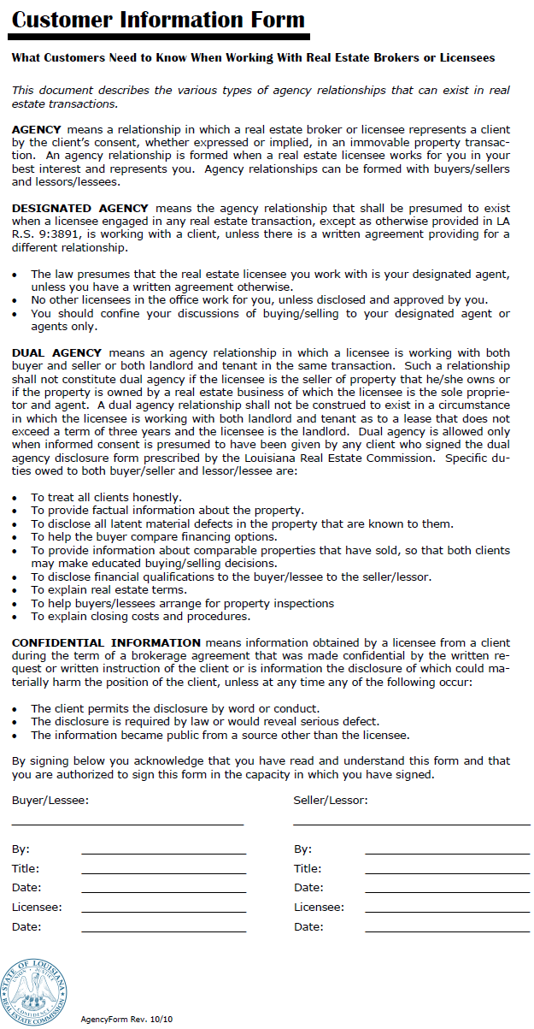
EXHIBIT B
DUAL AGENCY DISCLOSURE
Exhibit C
Flood Determination Disclosure
FLOOD DETERMINATION DISCLOSURE
Property Address: ________________________________________________________
The Federal Emergency Management Agency (FEMA) has implemented a nationwide effort to update and modemize flood hazard maps. Due to this effort, some parishes have finalized and adopted their new f100d hazard maps and some parishes arc in the preliminary stages of adopting their new flood hazard maps.
In the parishes that have not adopted their new f100d hazard maps, preliminary f100d hazard maps have been or will be published and made available for public consideration, comment and appeal prior to the adoption and finalization of the maps. As a result, the current information provided to Sellers or Buyers regarding property flood risk is based on information in the aforementioned preliminary flood hazard maps. Real Estate Agents and Brokers cannot guarantee the accuracy of information provided in the preliminary flood hazard maps which are subject to change upon adoption and finalization.
In the parishes that have adopted their new flood hazard maps, the information provided is final and should not change unless the new and updated f100d hazard map is amended or revised.
Whether the parishes' flood hazard maps are preliminary or final, Sellers and Buyers are strongly encouraged to contact the following agencies for the most current and accurate information:
1. Parish Planning and Zoning Office and/or Parish Flood Plain Manager for the parish the subject property is located in
2. f1oodmaps.1suagcentcr.com
3. https:llmsc.fema.gov
4. www.floodsmart.gov
In acknowledgement of the aforementioned, Seller and Buyer agree(s) to indemnify and hold harmless the Real Estate Agents and Brokers, and its subsidiaries, affiliates, officers, directors, members, employees, and agents, from any liabilities, costs, expenses, judgments, losses, damages, claims, causes of action or demands, including reasonable attomey fees, arising out of or in connection with, or in any way incidental to any representations, discussions or statements made by the Real Estate Agents and Brokers, and its subsidiaries, affiliates, officers, directors, members, employees, and agents relative to any and all Federal Emergency Management Agency issued flood hazard maps.

__________________________________________________________________________________________
Buyer Date Seller Date

__________________________________________________________________________________________
Buyer Date Seller Date
___________________________________________________________________________________________
Agent Date Agent Date
Exhibit D
Map and Description
SW OF NE, S OF THE N.O.T. & M. RR. THE N 24 AC OF NW OF SE, 20-6-6. (141-234)(332-337)(387-1019)(394-6-8-10)(520586)

