Butler Farm Land, Hilger, MT
Location: 18 miles NW of Hilger, MT on Salt Creek Road
435 +/- total acres
391 +/- acres tillable (127 +/- in alfalfa mix)
43.8 acres in grass
Gentle rolling terrain
County road access (Salt Creek Road)
No improvements. Not perimeter fenced.
No current water wells
Mineral rights included with sale.
Leased for 2021 crop year
Wheat base: 151.6 acres Oat base: 8.4 acres Barley: 16.3 acres
Established yields: Wheat 27 bu./ac Oats 42 bu./ac. Barley 36 bu./ac.
Price: $696,000
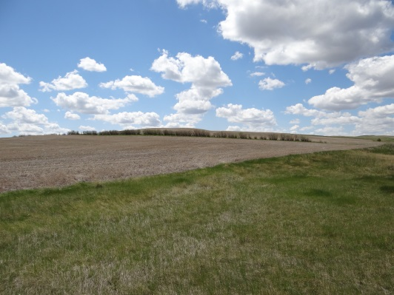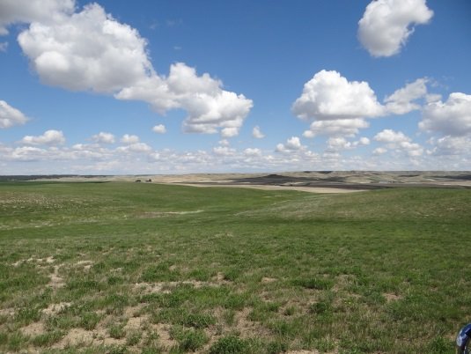


408 West Main Street, Lewistown, MT 59457
www.shobeauction.com
Jayson Shobe 406-366-5125
Dave Phillips 406-366-2750

