

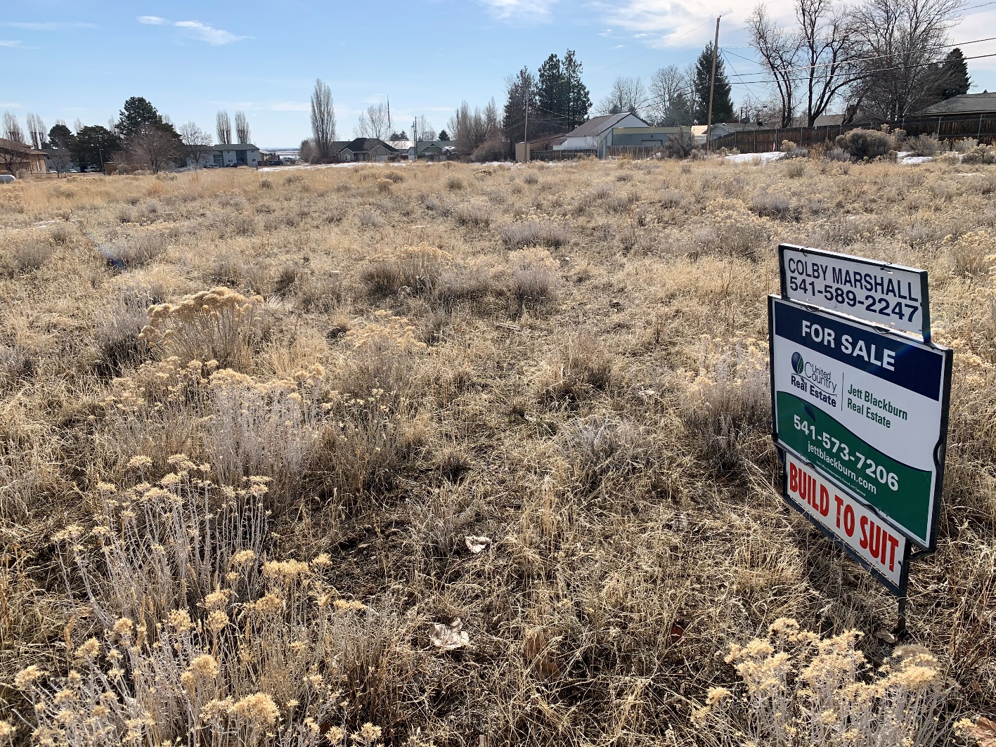

Tennyson Avenue Buildable Lots

$35,000 - $44,000


Presented by
Colby Marshall
Jett Blackburn Real Estate
707 Ponderosa Village, Burns OR 97720
Phone (541) 573-7206 * Fax: (541) 573-5011
Contact Card
colby@jettblackburn.com
www.jettblackburn.com

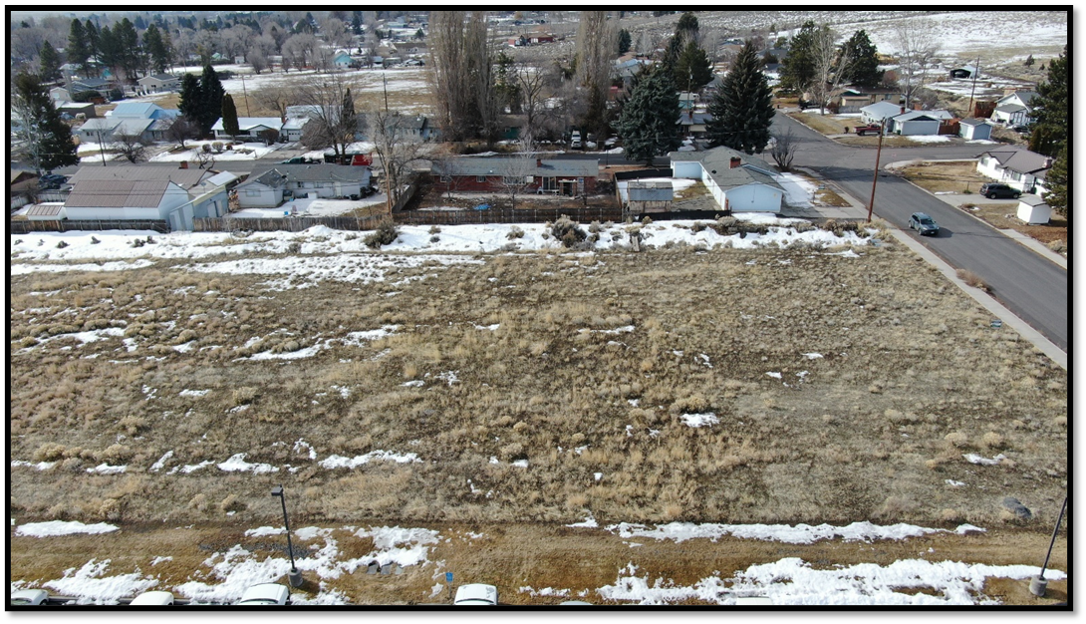

LEGAL DESC: T23S R30E Sec 23, Sec 14
LOT SIZE: Parcel 1 - .57 acres – 24,850 sqft (+/-)
Parcel 2 - .57 acres – 24,850 sqft (+/-)
Parcel 3 - .57 acres – 24,850 sqft (+/-)
Total – 1.71 acres – 74,550 sqft (+/-)
PRICE: Parcel 1 - $44,000 - 446 West Ridge Ave, Hines OR 97738 Parcel 2 - $42,500 - 436 West Ridge Ave, Hines OR 97738
Parcel 3 - $35,000 - 428 West Ridge Ave, Hines OR 97738
TAXES: Parcel 1 – Tax Lot 111 - $376
Parcel 2 – Tax Lot 142 - $376
Parcel 3 – Tax Lot 148 - $376
ZONING: Residential
WATER: City of Hines; service lines
SEWER: City of Hines; Discharge line run under Tennyson Avenue
POWER: Oregon Trail Electric Cooperative
FINANCING: Cash & bank financing
REMARKS: Residential lots in the heart of Hines, Oregon! There are over 74,000 square feet of space located just minutes away from schools and community services. Located in a central location and a desirable area, construction opportunities are waiting for the development of your dream home!

Portions of the lots are overlayed by FEMA 100 year floodplain

https://map1.msc.fema.gov/firm?id=4100850001C

