United Country Ozark Realty
Information Sheet

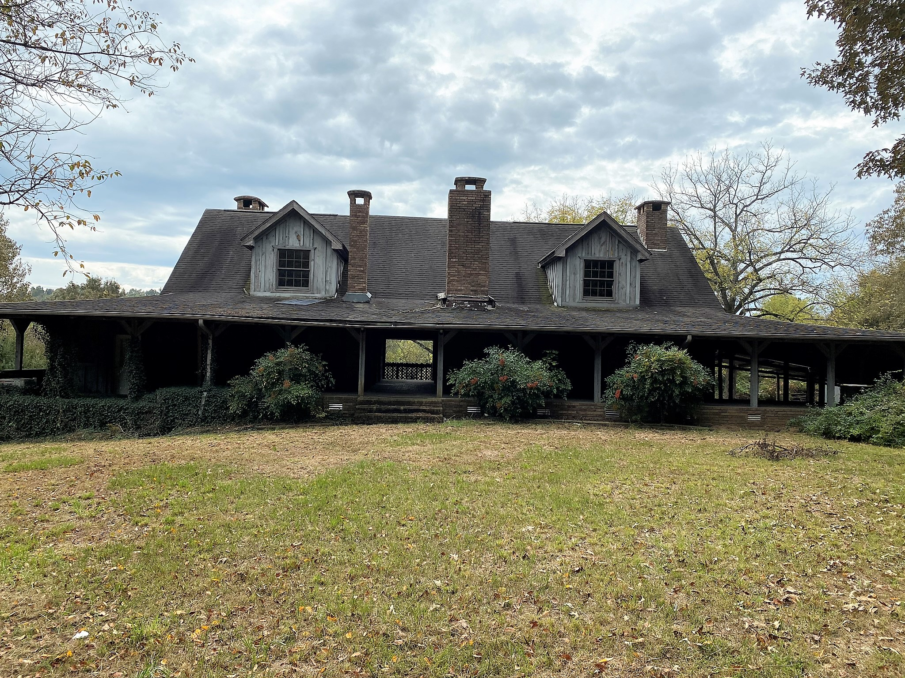United Country Ozark Realty
PO Box 158
Melbourne, AR 72556

Phone: 870-368-4155

Fax: 870-368-4165

Email: ozarkrealtyinc@gmail.com

LISTING #5556

PRICE $285,000

PROPERTY ADDRESS: 193 Kings Rd, Mt. Pleasant, AR 72561
Land | Home
Acres: 98  Fencing: None  Septic or Sewer: Septic  Closest Town: Mt. Pleasant  Type of Road: Gravel  Outbuilding(s): 1  Estimated Taxes: $2,369  Internet Service Provider: Dish  Television: Dish  Estimated Sq. Ft.: 3303 Main &  Upstairs level  *Dimensions and/or square footage supplied by the County Tax Assessor Office  Approximate Age of Home: Unknown | Bedrooms: 3  Baths: 3  Living Room Flooring: Carpet  Kitchen Flooring: Hard Wood  Kitchen Cabinets: Wood  Fireplace: Yes - 3  Type of Heat: Central  Type of Air: Central  Roof: Shingle  Foundation: Block  Basement: Partially finished - 2,442 Sq Foot  Garage/Carport: Carport  Appliances Staying: All
Comments:
Unique country home with 98 acres. Home features 3303 feet of living space in the main and upstairs level, and 2442 feet in a partially finished basement with a total of over 5843 under roof. Home features 3 bedrooms and could be made into a 4 or 5 bedroom, 3 baths and 3 fireplaces. The land has 2 big ponds and some good cleared land for cattle or horses. Priced at $285,000

