United Country Ozark Realty
Information Sheet

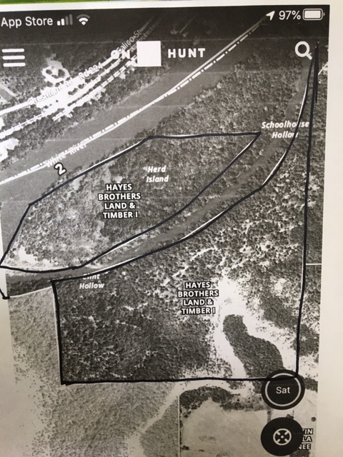
United Country Ozark Realty, Inc.
PO Box 158
Melbourne, AR 72556

Phone: 870-368-4155

Fax: 870-368-4165

Email: ozarkrealtyinc@gmail.com

LISTING #5442

PRICE $599,900

PROPERTY ADDRESS: 222 Culp Road, Calico Rock, AR 72519
Land | Home
Acres: 145  Water Source: None  Septic or Sewer: None  Electricity To Property: No  Closest Town: Calico Rock  Type Of Road: Rock  Amount of Cleared Land:  Amount of Timber Land: Mostly Timber  Fencing: Some  Outbuilding(s): None  Estimated Taxes: $198.00 | Own your own Island! Approximately 145 acres including a 40 acre +/- island in the beautiful White River. This property has great bluff views of the river with close to a 1/2 mile of frontage. Also, it joins the National Forest on the West side. Not many opportunities like this come along for development or other uses.

