Historic Carlinville, Illinois, has been called one of the “Best Small Towns in America.” (Norman Crampton, author of The 100 Best Small Towns in America)  Carlinville is rich in history and as a community we have preserved its beauty, making it one of the best small communities in America. Carlinville’s historic district has been on the National Register of Historic Places in Illinois since 1976. The elegance and architectural quality of the homes and buildings within the district, which covers most of the west and central sections of the city, is well worth visiting. Among the most significant sites are the 1876-vintage “Million Dollar” courthouse and the 1867 “cannonball” county jail, the Loomis House (St. George Hotel) on the square; St. Paul’s Episcopal Church at 415 S. Broad; The Federated Church at 122 E. Second South; the Saloon at 407 S. West St.; and the Old City Jail (also called “The Calaboose”) located at 115 N. Plum Street.

Carlinville is warm and welcoming, the community of Carlinville is centered on its picturesque town square, home to historic buildings, quaint shops and restaurants, and a beautiful gazebo. The city is also the seat of Macoupin County and is home to the majestic Macoupin County Courthouse, one of the largest in the country.

Carlinville offers small-town Americana at its best. Residents gather for summer concerts in the town square, cheer on top high school athletes, and gather to celebrate at events like the Macoupin County Fair and the annual Christmas Market.

A walk along shaded streets will introduce visitors to neighborhoods of Victorian mansions, stately brick Federals, brick streets around the Square, parks, historical buildings, and unique to the American dream of home ownership, the largest single collection of Sears homes in the United States.

Visitors can even retrace the original path of the Mother Road, Route 66. And, at just 1.5 hours from St. Louis and an hour from the Illinois state capital, Springfield, Carlinville is at the heart of regional metropolitan action.

As the only Carlinville in the world, this small city of 5,685 is a place that offers much to interest visitors. The centerpiece of the town is its turn-of-the century, brick-paved city square with its quaint central park that features a large cedar gazebo. The park is often used for weddings, open-air concerts, and ice cream socials. The gazebo is located in the very spot where a two-story brick courthouse once stood - and where Abraham Lincoln practiced law and wrote his longest legal brief on record.

The gazebo serves as the centerpiece of the historic town square

.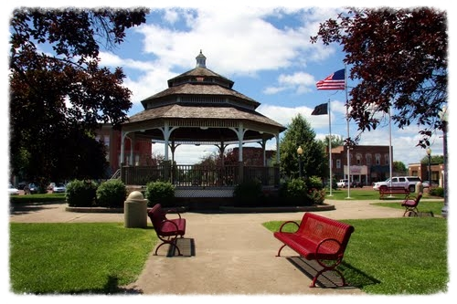

A stroll around the town square will reveal interesting architectural details in century-old buildings, as well as charming restaurants and shops that boast a history all their own. The town's adjoining historic district includes many significant sites, the crown of which is the “Million Dollar” 1876 vintage Macoupin County Courthouse. "Millionaire's Row" homes down East Main Street give testimony to the wealthy businessmen who made their fortunes in banking and commerce. The 1896 "cannonball" county jail, located south of the courthouse, is currently closed for repairs but still provides an interesting site.

The community sponsors a host of wonderful festivals and events throughout the year. One of the first major events is the spring festival at "Anderson Mansion," home of The Macoupin County Historical Society, It's one of two exceptional events held there each year. Located in and around the completely restored 1860 “Anderson Mansion,” these festivals are a great opportunity for crafters to show off their talents while the curators of the museum serve tasty homemade treats and hold guided tours of the home. Visitors can witness operating antique farm equipment and “good old days” demonstrations during these events. In May, over Memorial Day weekend, the annual spring festival features homemade strawberry shortcake along with all of the other activities. The third weekend of September offers the even bigger Fall Festival. Both events feature fun and entertainment for the entire family to enjoy.

The annual Macoupin County Fair, the oldest continuously held county fair in the state, is held in June on the fairgrounds located just north of the city limits. Entertainment in the grandstand, carnival rides, livestock and arts, demolition derby, tractor pull, and much more make it a great family outing.

The old county jail is a favorite photo subject for tourists.

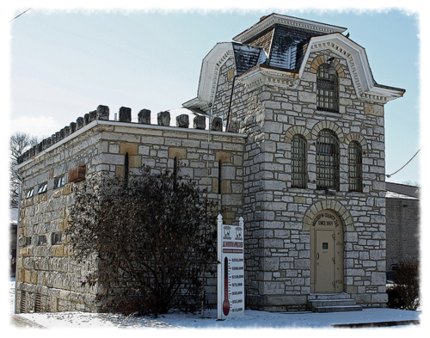

Beginning in 2015, Carlinville Winning Communities hosts an annual 4th of July celebration at the Macoupin County Fairgrounds. There are a number of car shows, new and antique, sponsored by local dealers and organizations. Area orchards sponsors fall apple and pumpkin festivals each year as well. Local clubs and organizations sponsor a number of entertaining events throughout the year, including a parade, carnival, and cookouts on the square. In addition to the standard fare, Carlinville offers a number of unique opportunities for participation in community activities.

Throughout the year there are a number of special sidewalk features, not only on the city square, but scattered throughout the city from the Walmart Shopping Center on the southwest end of town to the Carlinville Plaza on the north end.

A major event closing out each year is the “Carlinville Christmas Market.” This unique event is held the first weekend in December. Visitors delight in the festive atmosphere as they wander around and check out the handcrafted fine arts, folk art, and craft items. The beautifully decorated town, accented by the music of traditional holiday carolers, is a vision to behold. Children delight in visiting with Santa and participating in the many activities awaiting them during this event, while adults enjoy the unique shopping experience, entertainment, and the overall beauty of the event.

Cruise the Mother Road and get your kicks on the original Route 66! From 1926 through 1930, Route 66 followed State Road 4, the first fully paved highway in Illinois. The historic route stretched from Chicago to East St. Louis, passing through the heart of Carlinville. In 1927, Route 66 signs were posted across the eight states between Chicago and Santa Monica, California. However, by 1930, Illinois and Kansas, with their 12-mile stretch of the famed road, were the only states, which could boast of having a paved highway. During the '30's and '40's, the section of Route 66 between Springfield and Staunton was relocated twice.

Although Route 66 was decommissioned nationally in 1985 (due to the Interstate Highway System), its popularity and mystique never died. Ten years later, the Illinois Department of Transportation officially recognized the Route 66 revival movement and posted historic markers along its length of the "Main Street of America." Visitors to Carlinville will find it easy to retrace the original Route 66 pathway.

Among the Route 66 attractions:

* Elite Classic Car, 1123 N. High St. - Classic and vintage autos, toys, signs and memorabilia
* Sears Homes. Area bounded by Rice, High, University, Wilson, Sumner and Whitley Streets - Largest contiguous group of Sears Catalogue Homes in U.S. (Tours available)
* Lou’s Automotive and Performance. 703 N. Broad St. - Restoration and service of classic, vintage and performance autos
* Rt. 66 Experience Hub. NW Corner of N. Broad and Nicholas Streets - Illinois Rt. 66 Scenic Byway informational sign in the City Hall parking lot
* “Moo-saics." 265 N. Broad St. - Unique farm mosaics on the Farm Credit building
* Carlinville Town Square. Dine and shop where Lincoln once walked, on a classic town square with brick-paved streets and Victorian cast-iron storefronts. It is the only Town Square in Illinois that Rt. 66 went completely around.
* Reno’s Rt. 66 Room & Murals. 518 N. Side Square - Don’t miss the “hidden” Statue of Liberty mural outside
* Rt. 66 Wayside Exhibit. North side Carlinville Square Park - Illinois Rt. 66 Scenic Byway informational sign
* Old ITS Interurban Railway Station. 125 N. West St. - Former station for the Illinois Terminal System interurban railway that served towns from Springfield to St. Louis, historic photos of station inside
* Old Lynch Rye Ghost Sign. West Street across from old ITS Station - Remains of classic advertising sign
* Hawthorne Coffee Shop and Gifts. 242 E. Side Square - Collection of local merchandise for sale
* Original site of Ariston Café. 230 E. Side Square - Where the Rt. 66 landmark restaurant originated back in 1924. Now the Sun Thai and Route 66 Craft Beer and Wine
* Loomis House. East Side Square - Grand hotel, built in 1869; rumored to be haunted
* Taylor’s Mexican Chili. East Side Square. - World-famous chili parlor since 1904
* Chamber of Commerce Visitors Center. 112 N. Side Square
* Selz Royal Blue Shoes “ghost sign” - Remains of classic advertising sign on the side of the Visitor’s Center
* Site of Lincoln’s Speech. SE Corner of Broad and First South Streets - Where Abraham Lincoln spoke in his race against Stephen Douglas for the U.S. Senate, August 31, 1858
* Million Dollar Courthouse. 200 E. First South St. - Begun as a $50,000 project, the cost ballooned to more than $1 million in 1870, the most magnificent courthouse in Illinois (Tours available)
* Old County Jail of 1869. 203 E. First South St. - Cannonballs in the walls kept prisoners from escaping; in use for 119 years until 1988
* Mary Hunter Austin Home. 654 E. First South St. - Childhood home of noted author of the American West, a friend of H.G. Wells, Jack London, Diego Rivera and Ansel Adams (Private residence)
* Crabby’s Supper Club. 18838 IL Route 4 - Classic 1950-era supper club
* Carlin-Villa Motel. 18891 IL Route 4 - Classic 1960s era motel

A row of Sears kit homes in Standard Addition.

/>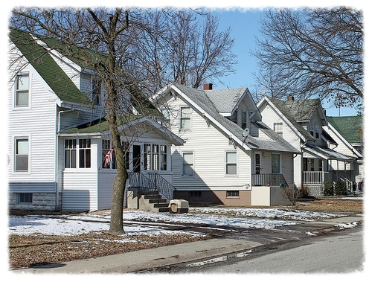

Other areas that attract attention are the world's largest contiguous collection of “Sears & Roebuck” catalog homes in the country, all within a 9-block radius on the north end of town.

Standard Oil officials found a solution to this crisis in an unlikely place; Sears and Roebuck. For the first time, people could order home kits in a variety of models through the Sears mail order catalog. Eight different models were selected for Standard Addition, ranging in price from $3,000 to $4,000, with the company placing an order for $1 million for homes, the largest in Sears history. By the end of the 1918, 156 of the mail order homes had been placed within a nine-block neighborhood in the northeast side of town.

In 1926, Standard Oil executives determined they could buy coal cheaper than mining it themselves, and they made the decision to close the mines. The closure devastated the town and required years before it fully recovered. The workers moved away, mostly to other mines, and abandoned the housing to the ravages of time. Standard Addition remained largely vacant until the mid-1930s when the houses were offered for sale to the public. Families could purchase one of the run down five room homes for $250 and a six-room model for $500. Even in the midst of the Great Depression, comparable homes were selling for $4,000, so it was an incredible bargain for lucky buyers.

A well-preserved home in Standard Addition.

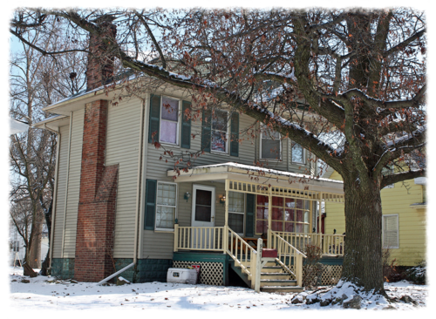

Today 152 of the original 156 homes still stand. Four no longer exist on their original sites; three were destroyed by fire and one was moved to the country. As the largest single repository of Sears Homes in the United States, Standard Addition has been the subject of several documentaries and has attracted the attention of architects and nostalgia buffs from around the globe.

In 2014, the Standard Addition Neighborhood Association (SANA) was formed to begin restoration of the area and celebrate the historic value of the Sears Home and coal mining heritage.

