United Country Ozark Realty
Information Sheet

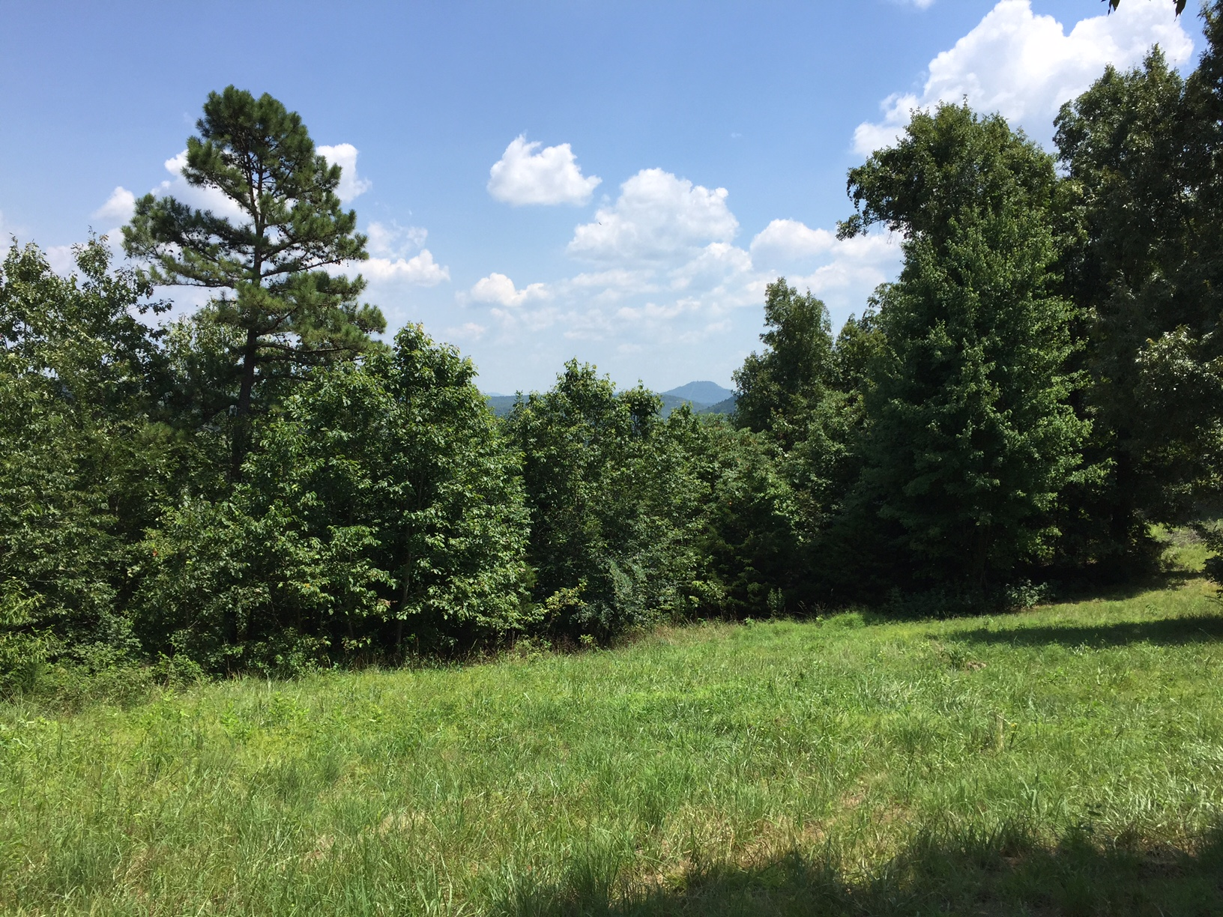
United Country Ozark Realty, Inc.
PO Box 158
Melbourne, AR 72556

Phone: 870-368-4155

Fax: 870-368-4165

Email: ozarkrealtyinc@gmail.com

LISTING #5490

PRICE $49,900

PROPERTY ADDRESS: 112 S. Moccasin Creek, Calico Rock, AR 72519
Land | Home
Acres: 4.920 Lot 7  Electricity To Property: Yes  Closest Town: Calico Rock  Fencing: None  Type of Road: Gravel  Amt. of cleared land: 1 Lot  Amt. of timbered land:  Outbuilding(s): None  Estimated Taxes: $200 | GREAT BUILDING LOCATION IN GATED COMMUNITY  Looking for a place to build that dream home or get away cabin? You need to see this ridge top lot with long distance view in a beautiful gated community. Owner financing is available. Contact Dale Ivy with United Country Ozark Realty at 870-373-3677 today!

