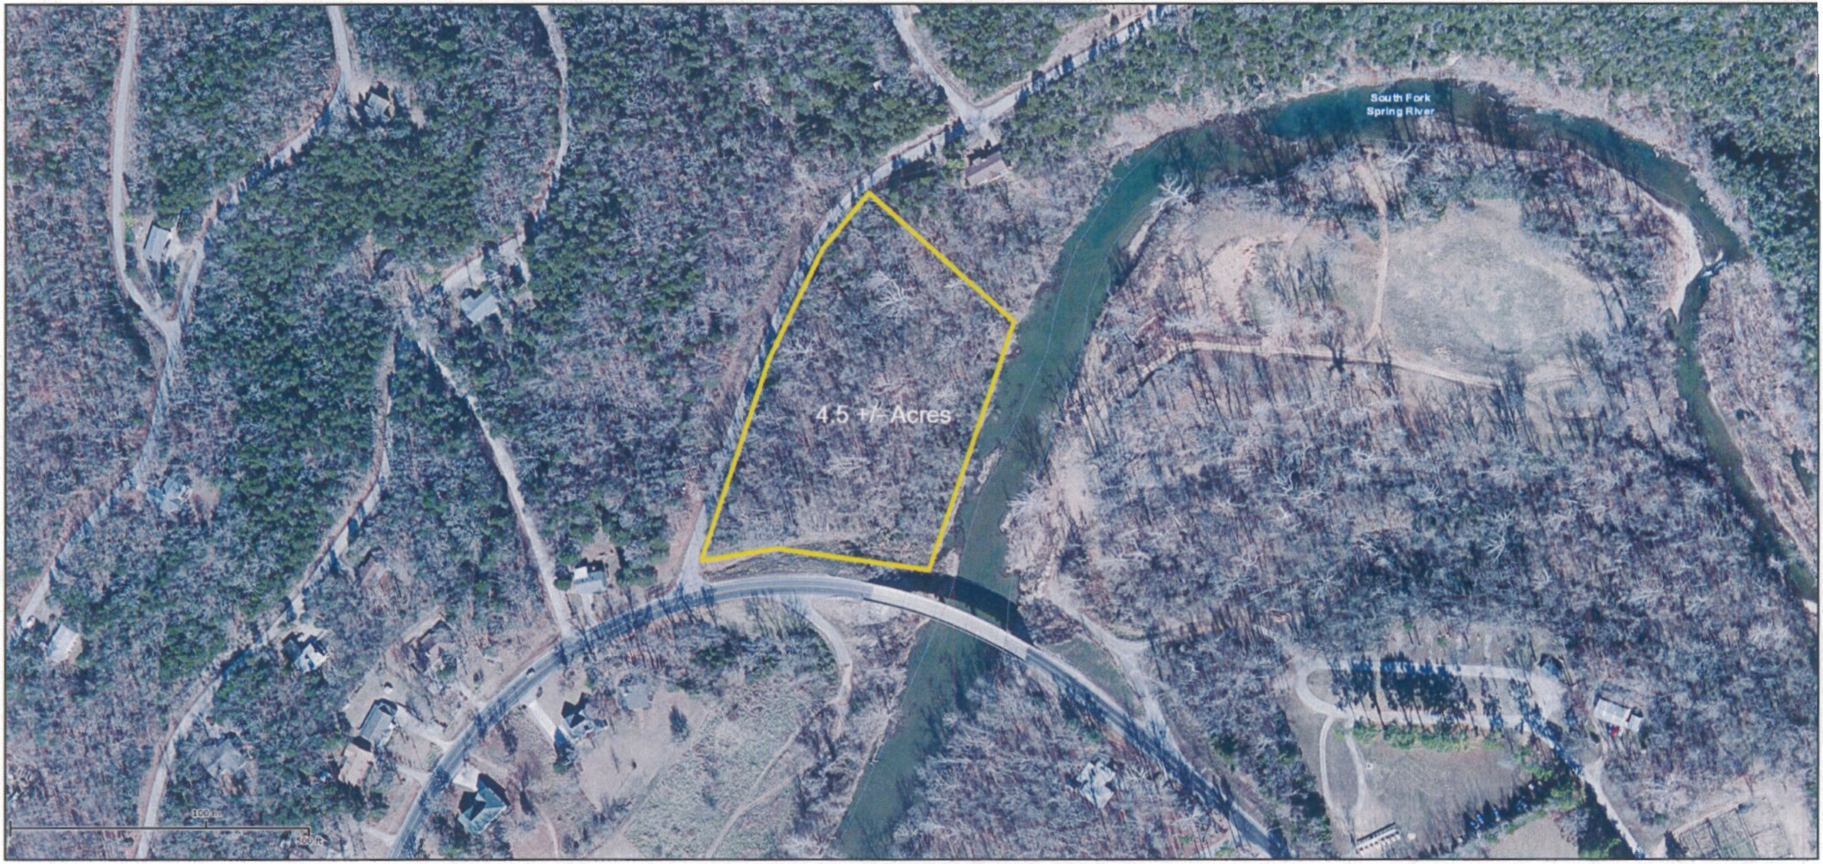

**N**

Produced from the ( **Southfork River Pr op e r t y )**

**AGFC Mapper**

**A**

Wed Apr 13 2016