OKLAHOMA CITY WINTER ART GLASS AUCTION

Thursday May 18th AT 2PM

PREVIEW 11:00 NOON TO THE END OF THE SALE

AT THE PARADISE EVENT CENTER YUKON OK

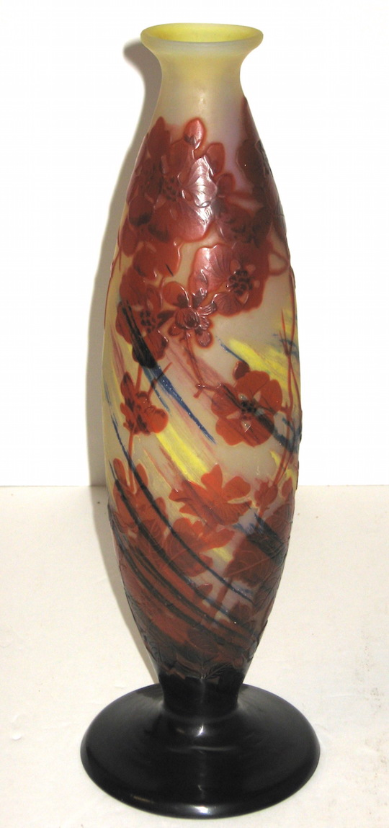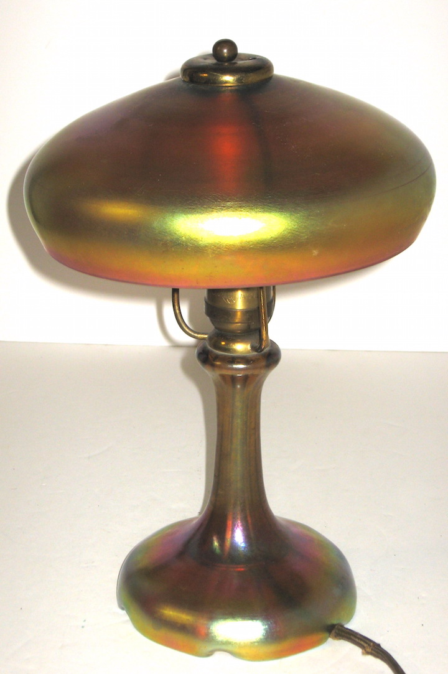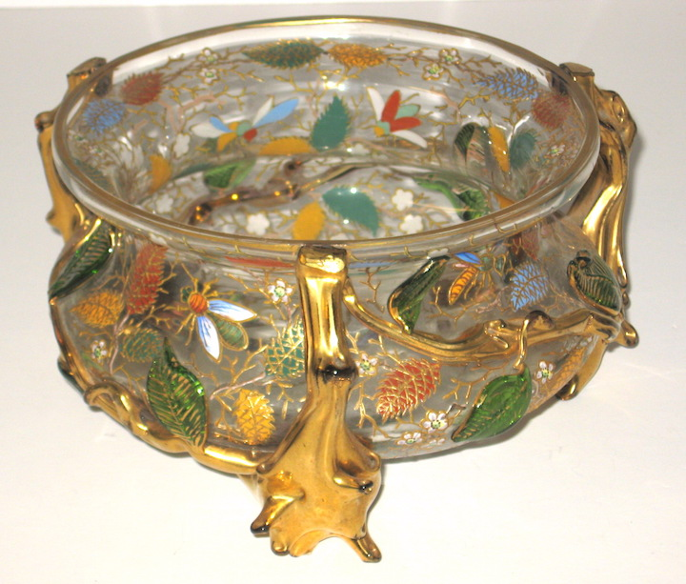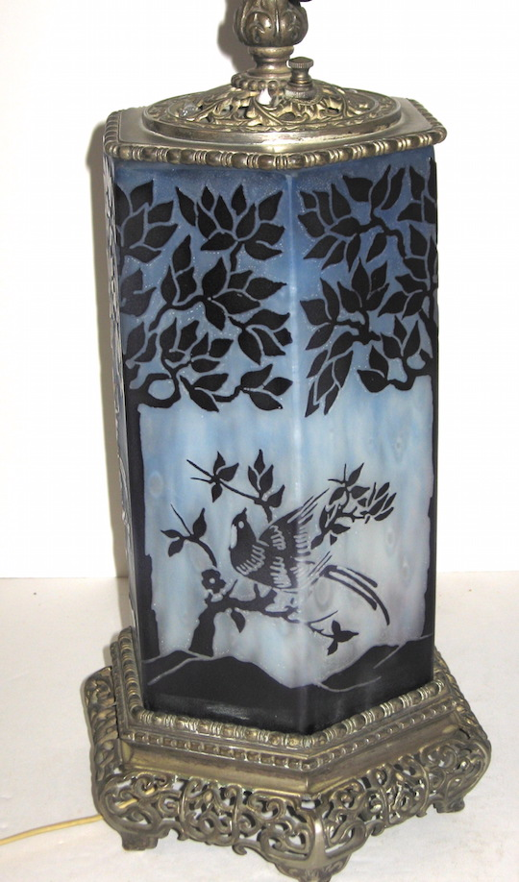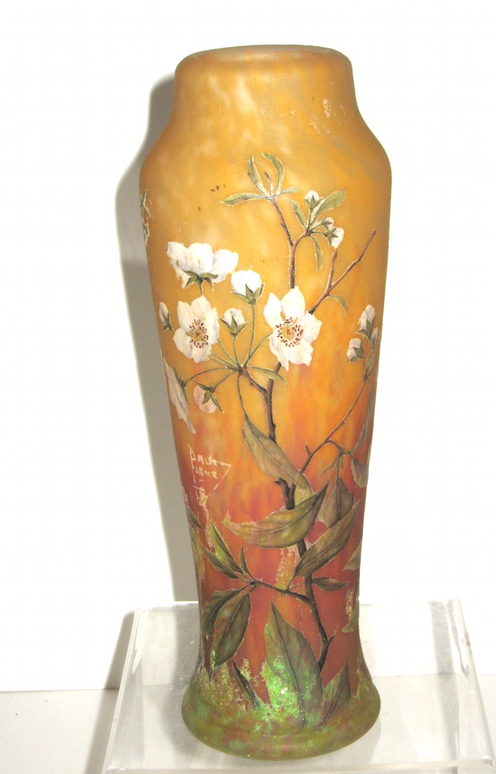

**450 E. MAIN ST, YUKON OK 73099**

**JAREMOS ESTATE SALES OF NAPERVILLE IL, IN CONJUNCTION WITH HEARD AUCTIONS OF CLINTON OK, PRESENT A MAGNIFICENT COLLECTION OF ART GLASS, DOORS OPEN AT 11PM.**

GLASS HIGHLIGHTS: **STEUBEN**: INCLUDING RARE ACID CUT BACK LAMP, RED AURENE SHADES, GOLD AURENE LAMP, BLUE AURENE TWO HANDLE VASE, LACE COMPOTE, MILLIFIORI CANDLE LAMP BASE, DARK BLUE JADE VASE, EARLY STEUBEN PRINT MATERIAL, AND MORE **TIFFANY**: GOLD FLOWER FORM, EARLY DECORATED VASE. **LOETZ**: TWO HANDLE VASE. LARGE GROUPING OF **MOSER**. **DAUM** **NANCY**: DIMINUTIVE WINTER SCENES, DIMINUTIVE BLACKBIRD, DOGWOOD BLOSSOM, TWO HANDLED VASE WITH PURPLE FLOWERS, MONUMENTAL OPALESCENT VASE. **GALLE**: EARLY BOWL WITH RAMPANT LION, TALL CRIMSON CAMEO VASE WITH SWEEPING RAINBOW BACKGROUD, **MULLER, SCHNEIDER, LEGRAS, LAMARTINE.**  **WEBB** CAMEO INCLUDING A THREE COLOR INK WELL, **STEVENS AND WILLIAMS** ROSE DU BERRY. **PAIRPOINT, HAWKES**, **AND MT. WASHINGTON**. CONTEMPORARY GLASS BY **KENT IPSEN, RICHARD JOLLEY, JOHN LEWIS, DAVID HUCHTHAUSER, KREG KALLENBERGER**, **CHARLES LOTTON,** **JOHN LOTTON,** **SATAVA** VASE AND JELLY FISH PAPERWEIGHT, **JOSH SIMPSON**, RARE **VANDERMARK** PUNCHBOWL AND PILSNERS**.**

OTHER ITEMS OF INTEREST: MAGIC LANTER SLIDES, INDIAN RUGS, GOLD AND SILVER JEWELRY, WARREN G HARDING SIGNED DOCUMENT, LARGE COLLECTION OF SILVER OVERLAY PORCELAIN AND GLASS.

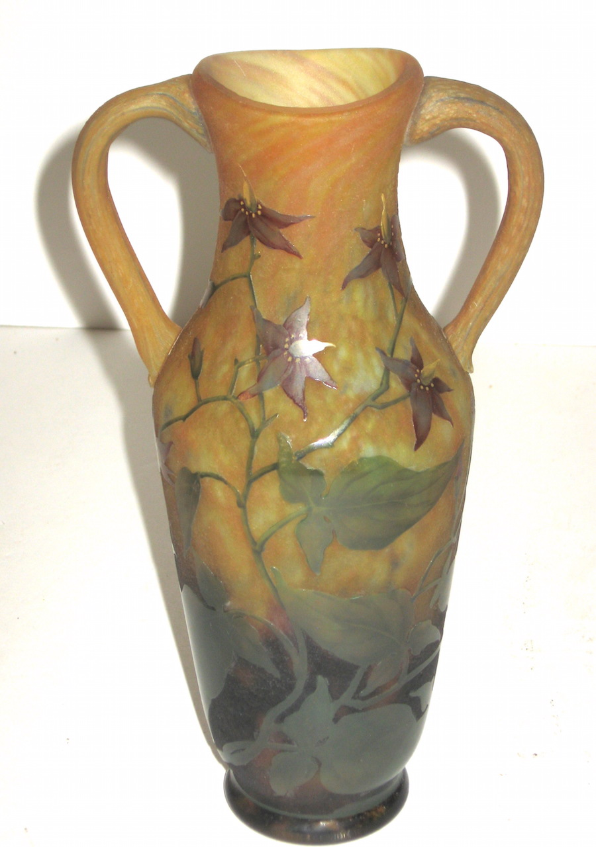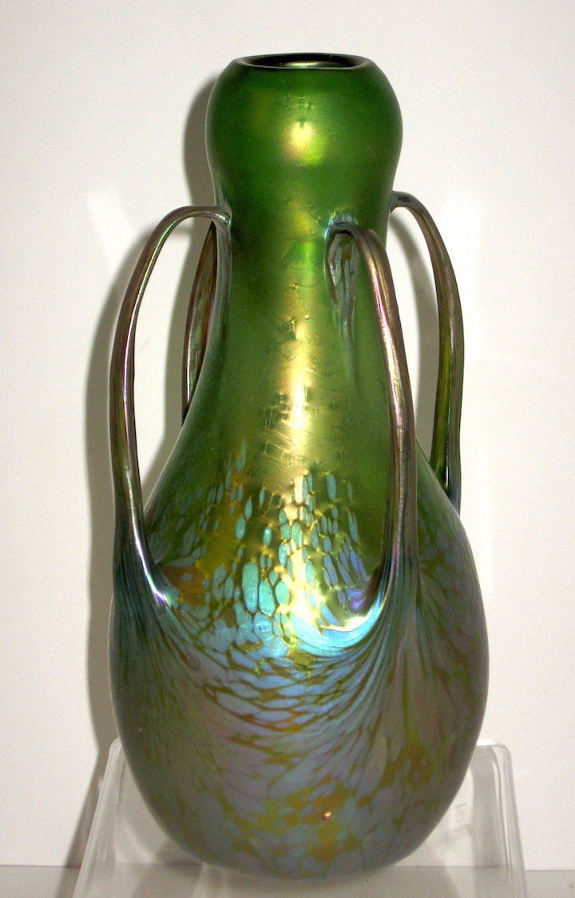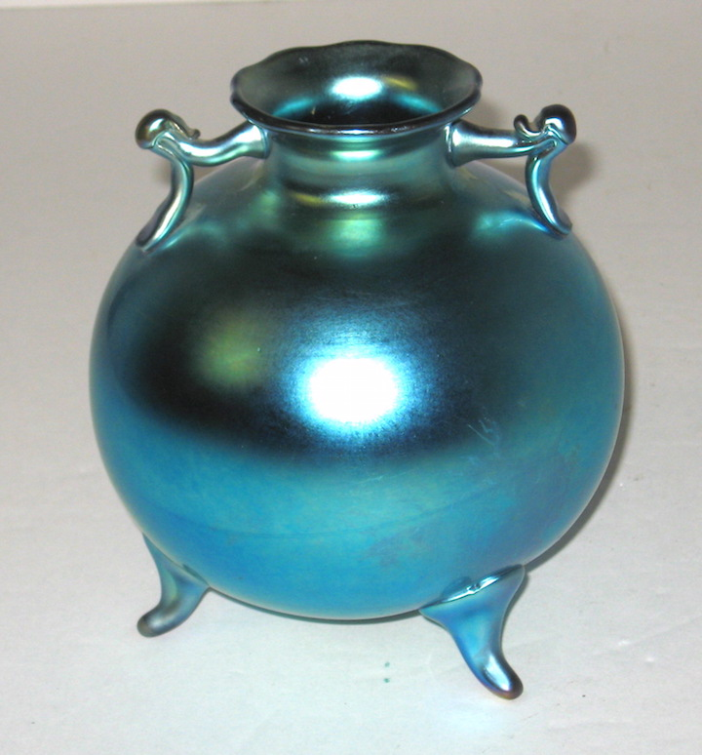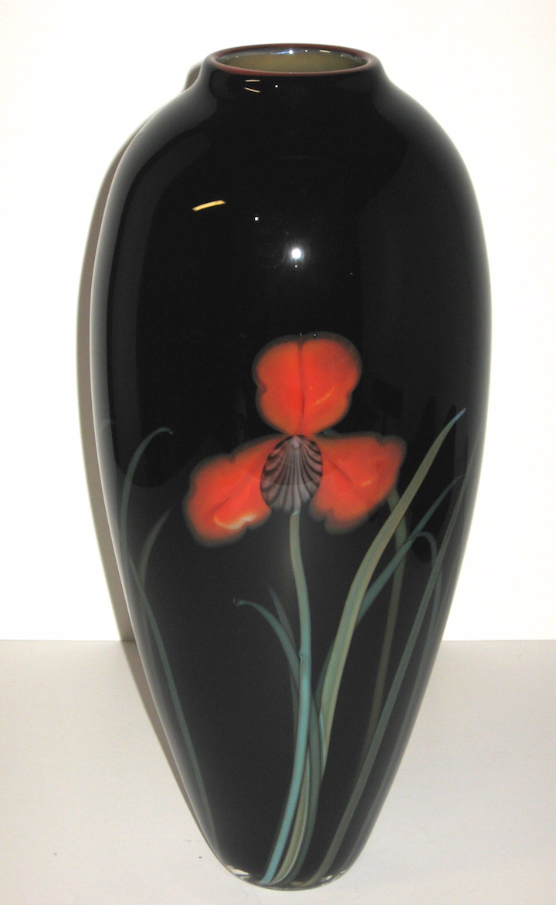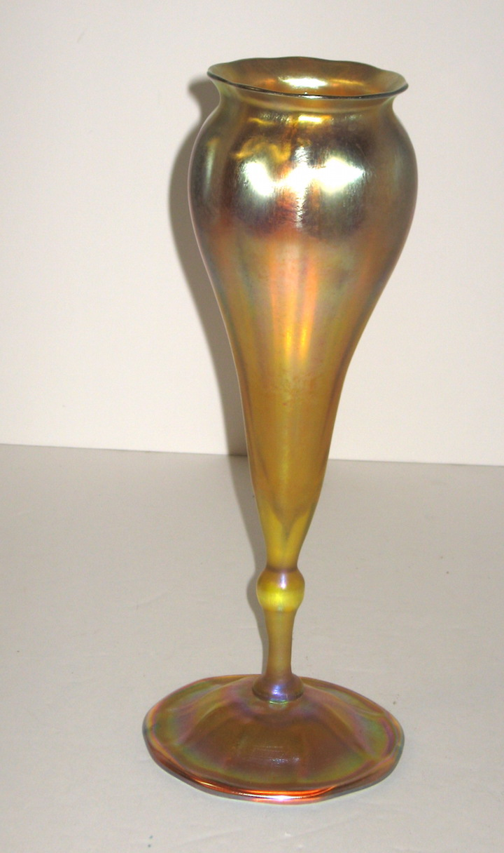

**Condition of sale: All items must be removed by the end of the sale. A 15% buyers premium will be charged (3% discount for cash or check). We take cash, check, AMX, Visa, MasterCard. Ok sales tax will be charged unless a valid resale certificate is on file. Catalog online at** [**www.liveauctioneers.com**](http://www.liveauctioneers.com)

**FOR FURTHER INFO:** [**www.jaremos.com**](http://www.jaremos.com) **or call Bruce Orr at 630-248-7785**

